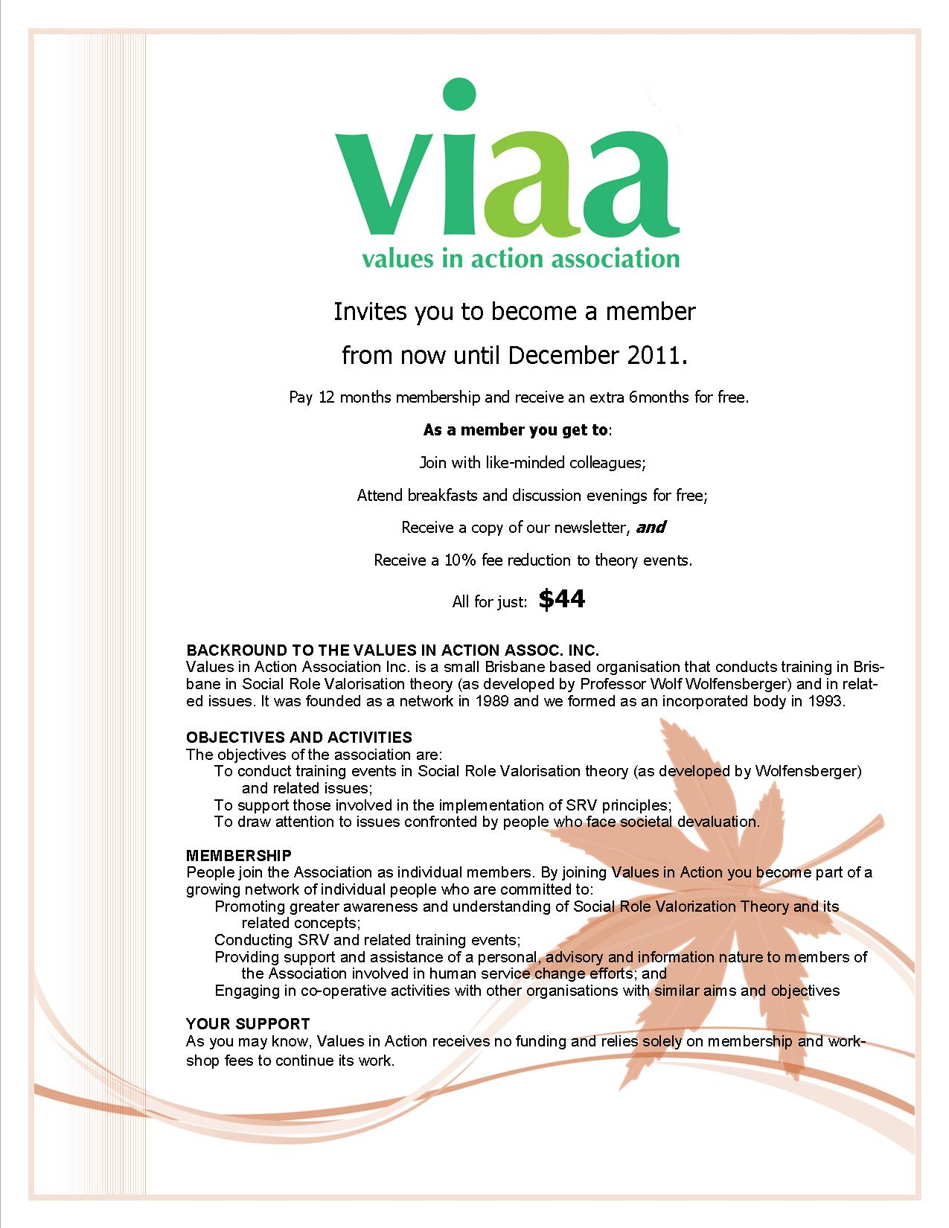
Invites you to become a member
for 2018

As a member you get to:
Join with like-minded colleagues;
Attend breakfasts and discussion evenings for free;
Receive a copy of our newsletter, and
Receive a 10% fee reduction to theory events.

All for just:
$44 (or $5.50 concessional) gst included

TAX INVOICE for Values in Action MEMBERSHIP
CALENDAR YEAR 2018
Issued: 19 September 2017

Name:

Post Code:

Where do you work/what organization are you associated with:

Phone:

e-mail:

Cheque Cash Direct Deposit

BSB: 484-799 (Suncorp)
A/c name: Values in Action Association Inc.
Account No. 0414 77931
Pls use your name as a unique identifier!
Amount Paid: Date Paid:

You choose your Membership Fee: $44 or
$5.50 concessional (person with a disability, family member, fulltime students, just can’t afford the full amount)
Amounts include GST. Values in Action ABN: 53 781 283 376

viaainc@gmail.com
PO Box 1247
Milton BC 4064
www.viaainc.org.au

