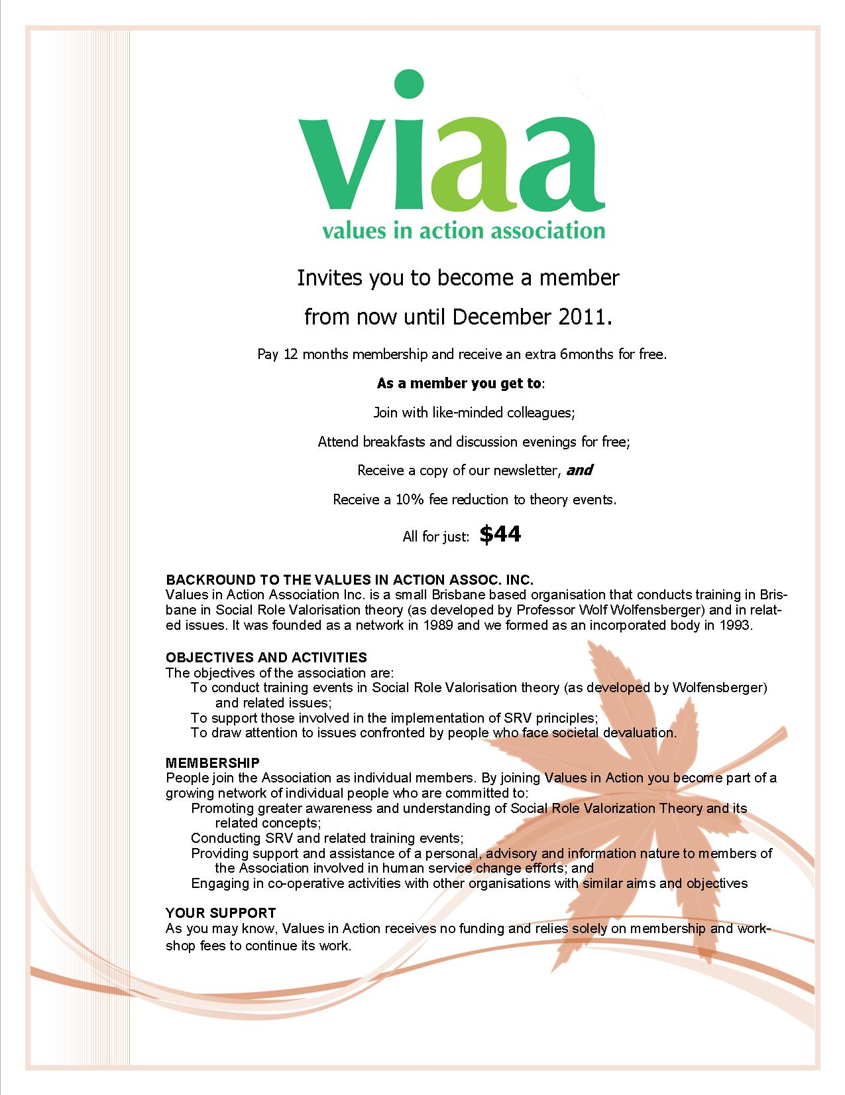
Invites you to become a member
for 2015
As a member you get to:
Join with like-minded colleagues;
Attend breakfasts and discussion evenings for free;
Receive a copy of our newsletter, and
Receive a 10% fee reduction to theory events.

All for just:
$44 or $5.50 concessional

TAX INVOICE for Values in Action MEMBERSHIP
CALENDAR YEARS 2015
Issued: 6 December 2014

Name:

Address: Post Code:

Where do you work or what organization are you associated with:

Day Phone: Mobile:

e-mail:

Chq encl: Date Paid:
You choose your Membership Fee: $44 or
$5.50 concessional (person with a disability, family member, fulltime students, just can’t afford the full amount)
Amounts include GST. Values in Action ABN: 53 781 283 376

DIRECT DEPOSIT
Suncorp-Metway:
Account Name: Values in Action Association Inc:
BSB: 484-799: Account Number: 0414 77931
Pls use your name as a unique identifier!

viaainc@gmail.com
PO Box 1247
Milton BC 4064

